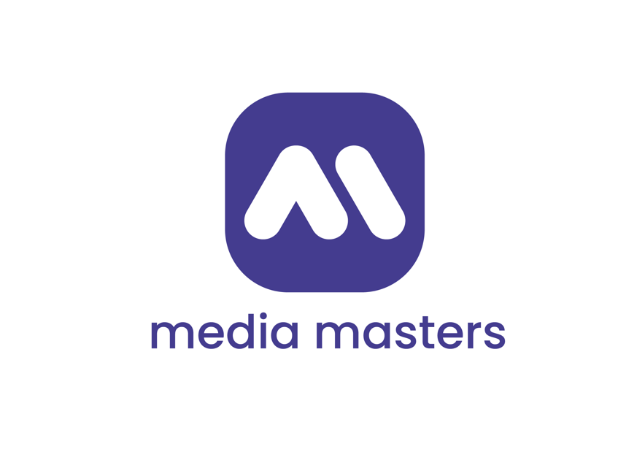

WORK PACKAGE No. 35
WORKSHOP
"PRESENTATION AND DEMONSTRATION OF THE EDUCATIONAL GAME AND MOBILE APPLICATION MEDIA MASTERS​

Presented by
Sofia University "St. Kliment Ohridski"
Faculty of Journalism and Mass Communication
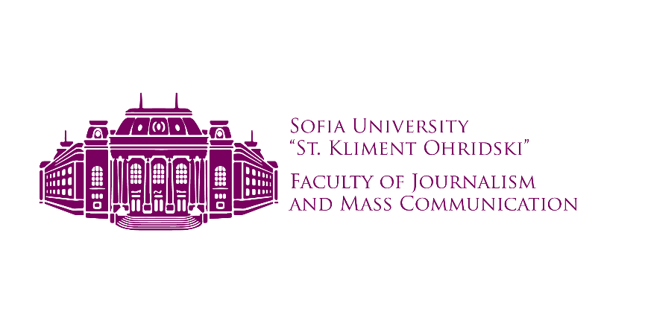
LOGO of the Partner

Document identification:

Full name of the project: | Media Masters : Improving media literacy
Project Acronym: | MEDMAS
Grant Agreement Number: | 101148165
CERV Program: | CERV-2023-CITIZENS-CIV - Citizen Engagement and Participation
Distribution level: | Public
Work package: | 35
Responsible partner  (Legal name and short name): | Sofia University "St. Kliment Ohridski"  Sofia University
PIC number: | 999887641
Authors | Prof. Dr. Vesselina Valkanova  Assoc. Prof. Dr. Mila Serafimova  Chief Assistant Dr. Yordan Karapenchev

EVENT DESCRIPTION
Event number: | Workshop 1
Event name: | Presentation and demonstration of the educational game and mobile application Media Masters
Type: | Workshop
In in situ / online : | in situ
Location: | Bulgaria, Sofia
Dates: | 30.04.2025; 07.05.2025; 14.05.2025
Website:
Participants
Women: | 38
Men: | 20
Others: | 0
From country 1 [Bulgaria]: | 56
From country 2 [North Macedonia]: | 1
From country 3 [Ukraine]: | 1
Total number of participants | 58 | Of the total number of countries: | 3
Description
Provide a brief description of the event and its activities.
- Workshop Summary
The three workshop sessions, held on 30.04.2025, 07.05.2025 and 14.05.2025 in rooms 74, 17 and 61 of the Faculty of Journalism and Mass Communication at Sofia University "St. Kliment Ohridski", were organized to present the demonstration version of the educational board game developed within the framework of the international project Media Masters .
Each session began with an introductory part, in which Prof. Dr. Vesselina Valkanova and Assoc. Prof. Dr. Mila Serafimova presented the goals, structure and significance of the Media Masters project . They emphasized the connection between the game approach and the development of media literacy, critical thinking and social engagement.
Then, Senior Assistant Professor Dr. Yordan Karapenchev presented the rules of the game and assisted the participants with the installation and use of the Media Masters mobile application , which is an integral part of the game process. In the application, each player chose a country and language, and this choice determined the specific scenarios and questions that could appear after scanning the QR codes on the game cards.
The main goal of the workshops was to explore the applicability of the board game as an innovative educational tool, contributing to the development of skills in recognizing fake news, misleading content and manipulations in the media discourse. Particular attention was paid to the behavior of the participants, the way they make decisions, discuss information and react to case studies inspired by real events and media situations.
A total of 58 participants participated in the game sessions, of which 56 were from Bulgaria and one each from Ukraine and North Macedonia. Before the start of the game, the participants were divided into teams of 3 to 6 people, so as to provide an opportunity for teamwork, debate and sharing of points of view. The game proceeded by moving around the playing field, drawing cards and interacting with the mobile application, which provided extended context to each scenario.
Each game session was moderated by Assoc. Prof. Dr. Serafimova or Sr. Asst. Prof. Dr. Karapenchev, who took notes during the game, observed the teams' behavior, and analyzed key moments of the game dynamics. After each session, a structured discussion was held with the participants, in which qualitative feedback was collected regarding the perception of the game, the logic of the questions, the effectiveness of the application, and opportunities for improvement.
Discussions revealed a strong positive perception of the game mechanics and scenarios, especially in the parts related to social media and fake news. Participants emphasized that the game format makes learning more accessible and interesting, while stimulating conversation, critical analysis and argumentation.
The attached table aims to systematize the information on the three workshops held, providing a clear breakdown of dates, rooms, number of participants, countries of origin and moderators. This structured presentation facilitates the analysis of participation, logistical organization and comparison between the individual sessions.
To facilitate reporting, all participants signed a common attendance list, which included all three dates. This ensured transparency, traceability, and accuracy in summarizing attendance and activity during the workshops .
It is important to note that two participants were present on two of the three dates and participated in the game sessions on both occasions. However, they are only counted once in the attendance list to avoid double counting when calculating the total number of participants.

Date | Hall | Number of participants | Countries of origin
30.04.2025 | 74 | 21 | Bulgaria (20), Ukraine (1)
07.05.2025 | 17 | 18 | Bulgaria (all)
14.05.2025 | 61 | 19 | Bulgaria (18), North Macedonia (1),
Table 1: Number of participants by hall

- Feedback from participants during game sessions

This type of feedback encompasses participants' reactions to the game's structure, how they interact with its components, and the dynamics of the game sessions. Comments and observations in this category are essential for assessing whether the game is accessible, engaging, and effective as an educational tool.
2.1. Understandability of the rules
Participants comment on whether the instructions are clearly formulated, intuitive, and easy to follow.
Participants indicated that the rules of the game are easy to understand and intuitive, allowing for quick orientation in the game process, even for first-time participants. However, a suggestion was made to add a short printed rulebook to be available during the game – for quick reference in case of need or clarification, especially in teams with new participants or in more complex game situations.
2.2. Balance between team and individual dynamics
The main comment is that although the game can be competitive, it becomes significantly more engaging and valuable when it is collaborative . Young people value the opportunity to discuss and assess whether a piece of information is fake news or not. However, in the current format, a challenge arises - one participant may not have an incentive to share their opinion because it would help an opponent who has the right answer. This gives rise to the idea of introducing a special collaborative game mode that encourages true teamwork and mutual support, without the competitive tension hindering the sharing of knowledge and arguments.
An interesting comment on the topic: "The game creates opportunities for leadership in the team, but also for equal dialogue."
2.3. Duration and pace of the game
The opinions gathered on the issue of game duration are diverse and include several important aspects. First, participants discuss whether the game duration is appropriate – not too long to avoid fatigue, but not too short to allow enough time for reflection and discussion. Some share that after a certain point they start to feel tired or lose concentration, which affects the quality of their participation. This raises the question of whether the current game length corresponds to an optimal learning or training block, for example 60 to 90 minutes. An appropriate duration would allow the game to be effectively integrated into a learning environment without exhausting young people’s attention or distracting them from other tasks.
In response to these observations, some participants suggested the idea of a “short mode” of the game, designed specifically for use in the classroom or during workshops where time is limited. This mode could shorten the game time while maintaining the essence and dynamics of the game. One possibility for implementing such a short mode is to reduce the amount of text in the questions, which would speed up the reading and comprehension process. Shorter questions would allow participants to make decisions more quickly without losing essential information, which is especially important in time-limited situations.
Another effective way to shorten the game would be to introduce a timer in the mobile application, which would limit the time for answering each question. After the specified time limit has expired, the game would automatically assume that the participant has given an incorrect answer, which would also add an element of tension and dynamism. This functionality would encourage quick thinking and prevent excessive delays in answers, while maintaining the competitive spirit of the game. Introducing a timer would make the game more dynamic and suitable for learning situations where time is strictly regulated.
2.4. Technical challenges
During the Media Masters demo session, some technical challenges were identified that can be easily overcome. Some participants reported difficulties with the visualization of certain elements, as well as with accessing multimedia content. In some cases, text repetitions and temporary delays were observed when working with the application.

Despite these difficulties, the overall impression of the game remained positive. Participants appreciated the innovative concept and the potential of the platform, expressing confidence that with future updates the technical aspects will be improved, contributing to an even more enjoyable and engaging experience.
*- Number of participants' notes)

3. Suggestions for gameplay improvement
During the final discussions after the game sessions, participants shared a number of ideas for improving and upgrading the game experience. These suggestions are informal, arising from the discussion, and are not part of the official scope or obligations of the Media Masters project . They have value as input for future development, adaptation to different educational contexts, and increasing player engagement.

3.1. Introduction of “role cards”
Each player on a team could be assigned a specific role (e.g. journalist, citizen, fact-checker, activist) that gives them a perspective on solving cases and making decisions. This would stimulate discussion from different perspectives and critical thinking.
3.2. “Bonus” or “penalty” spaces on the game board
A suggestion to include special fields with additional instructions – for example: “Skip a move”, “Choose between two scenarios”, “Answer without consulting the team” or “Get help from AI”. This would increase the unpredictability and dynamics of the game.
3.3. “ Debate round” after certain scenarios
After choosing more controversial or socially relevant scenarios (e.g. topics such as hate speech, election manipulation, media ethics), team participants can temporarily enter debate mode – defending a position based on the case. This will support the development of argumentation and communication skills.
Similar debates also took place spontaneously during the demonstration sessions, after participants answered some of the more difficult questions.
3.4. Marking the difficulty level of the cards
Proposal for categorizing maps by difficulty (easy / medium / hard) or by color marking.
3.5. Short game mode with timer
An idea to develop a “short mode” of the game, designed for situations with limited time (class, work meeting, quick trainings). The mode could include: 1) shortened scenarios with shorter questions, 2) limited time for answers via a built-in timer, 3) quick rotation between teams.
This form would allow the game to be more easily integrated into a classroom or seminar environment, without losing educational value.

4. Observation and analysis methodology
Each of the three game sessions was accompanied by a targeted and structured observation, with the aim of collecting qualitative information on the perception of the game, group dynamics, game behavior and the educational effectiveness of the tool. The observation and the subsequent discussion play a key role in the evaluation of the demo version and provide an empirical basis for conclusions and recommendations.
4.1. Moderators and their role
Each session was moderated by a team member: Prof. Dr. Vesselina Valkanova, Assoc. Prof. Dr. Mila Serafimova, Sr. Asst. Prof. Dr. Yordan Karapenchev, who, in addition to presenting the project and the rules of the game, also acted as observers and facilitators of the process. During the game session, they took detailed notes related to:
- the behavior of the teams (initiative, dialogicity, internal organization);
- reactions to different types of scenarios (emotional, political, social, etc.);
- the use of the application (ease, slowness, need for help);
- questions raised by participants during the game.
After the game session, the moderators led a structured discussion in which participants had the opportunity to share impressions, criticisms, suggestions, and ideas for development. This verbal feedback was further documented in writing.
4.2. Form of observation
The observation was non-interventional and semi-structured – the moderators tried not to interrupt or influence the game process, except in cases where clarification was needed. Their notes included descriptive elements (what happened) as well as analytical comments (how it was perceived or what behavior was observed in a given situation).
The tools used include:
- notebook or electronic note-taking devices;
- pre-prepared observation questions and criteria (e.g. “Is every team member involved?”, “How long does it take to solve a scenario?”);
- classification of impressions by key topics (e.g. game mechanics, application, educational value, etc.)
4.3. Processing and interpretation
The information collected was synthesized after each session through discussion between the moderators. This allowed:
- detecting recurring themes or reactions;
- identifying difficulties or ambiguities;
- validation of ideas proposed by more than one participant;
- building a typology of feedback used in the analysis by sections.
4.4. Limitations of the methodology
It is important to note some limitations in the methodology:
- Relatively limited number of participants (58), although distributed across three different sessions;
- Predominant representation of one country (Bulgaria);
- Feedback was collected verbally and informally, without survey instruments or quantitative indicators;
- Two participants participated in more than one session, which may have affected the dynamics within the teams or their evaluation of the game.
This methodology, although focused on qualitative and empirical observation , allows for reliable, realistic and applicable conclusions to be drawn about the performance of the demo version of the game, as well as the directions of its future development.

5. Conclusion
The three workshops conducted with the demonstration version of the board game under the Media Masters project provided a valuable opportunity for observation, testing and qualitative analysis of the game process in a real environment. Through careful moderation, structured observation and open discussion with the participants, significant data were collected on the perception of the game, its educational effectiveness and its potential for wider application. The reported reactions, ideas for improvement and suggestions for additional game mechanics are evidence of the high engagement of the participants and confirm that the game has real potential to become an innovative tool for the development of media literacy. Although some of the suggestions go beyond the scope of the current project phase, they can serve as a basis for future improvements and adaptations to different educational and cultural contexts.

HISTORY OF CHANGES
VERSION | PUBLICATION DATE | CHANGE
1.0 |  | Initial version

